USING QUOTES
When writing about a text, it is important to show that you have read it, or to find evidence from the text to prove the point you are making.

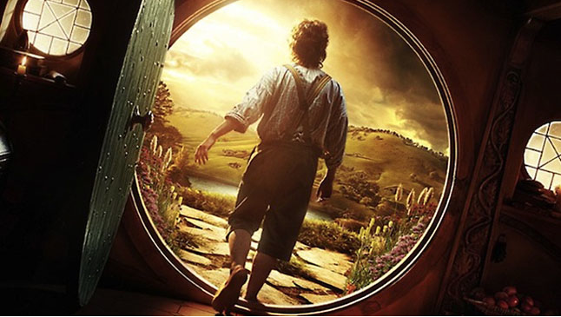
Example 1
Statement: The hobbit lived in a hole in the ground with a round door.

This makes a clear statement and tells the reader that hobbit homes had round doors.
The explanation would be better and people would believe me more, if I linked in a quote from JRR Tolkein himself. Mr Tolkein created the story and in his mind, he imagined a round entrance doorway. If he hadn’t have written it down, then Hobbiton would not have round doors into all the homes. So….instead, I would write it like this….
Example 2
Statement: The hobbit lived in a hole in the ground with a round door.
Example: Tolkein stated that Bilbo’s front door “had a perfectly round door like a porthole, painted green, with a shiny yellow brass knob in the exact middle.”

This example shows that JRR Tolkein was very clear about the round doors that hobbits had in their homes. The quote is:
- Relevant to the subject. The quote used is about round doors, which is what I wanted to write about.
- In quotation marks. These marks “ show the bit that is taken exactly from the book. You should use these quotation marks to clearly show your quote.
- Integrated into the writing. This means that it flows on from what I was saying. It is a smoother way to include quotes than something like this…My quote to show this is. “It had a perfectly round door”etc
Write 5 statements (full sentences) about setting, character or theme in the book that you are currently reading. For each statement, include a quote to prove your point.
Activity:

