The Hobbit chapter 8
3 level guide

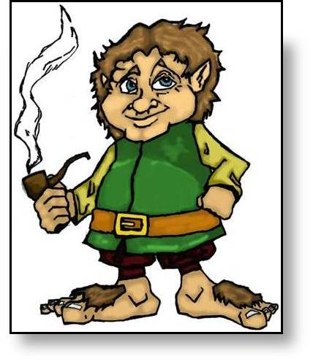
Level 1 questions
(straight from the text)

- The dwarves were impatient with waiting for Bilbo.
True or False
- They were very close to the edge of the forest. True or False
- Climbing down didn’t make Bilbo hot and miserable.
True or False
- Telling the dwarves about the breeze made them angry.
True or False
- All they had left to eat was scraps and crumbs. True or False

Level 2 questions
(between the lines of the text)
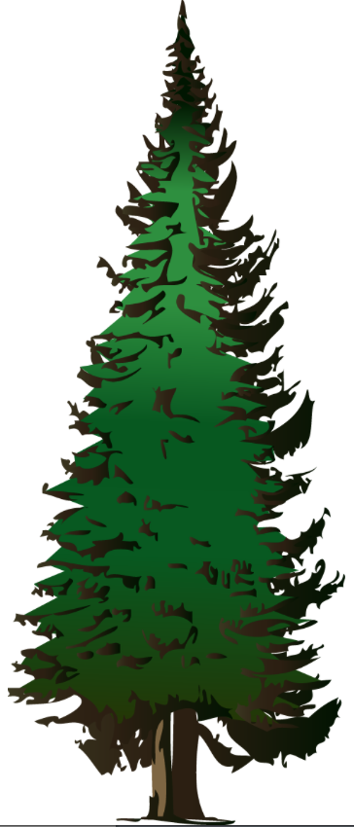
- Bilbo is not afraid of spiders. True or False
- Bilbo can see a sea. True or False
- Purple emperor butterflies do not like to live in the top of oak trees. True or False
- JRR Tolkein speaks directly to the reader when he says “As I have told you”. True or False
- Tuppence is a colloquial term that makes it clear that the dwarves did not care. True or False

Level 3 questions
(beyond the text and for discussion with one other partner)

- Hunger makes you incredibly bad-tempered. True or False
- An individual can be held responsible for a bad situation. True or False
- It is difficult when you are completely stuck in a situation. True or False
- When you are lost, you should climb a tree to get your bearings. True or False
- People who are starving should help themselves. True or False

