Hobbit Characters worksheet
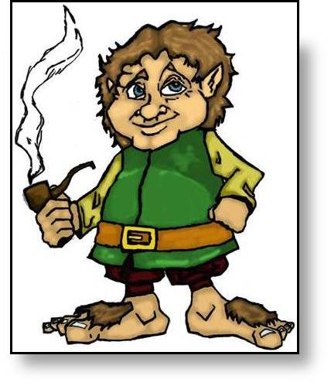
“I am like a burglar that can’t get away, but must go on miserably burgling the same house day after day,” he thought. “This is the dreariest and dullest part of all this wretched, tiresome, uncomfortable adventure! I wish I was back in my hobbit-hole by my own warm fireside with the lamp shining!” He often wished, too, that he could get a message for help sent to the wizard, but that of course was quite impossible; and he soon realized that if anything was to be done, it would have to be done by Mr. Baggins, alone and unaided.”  P71 | “I always meant to see you all safe (if possible) over the mountains,” said the wizard, “and now by good management and good luck I have done it. Indeed we are now a good deal further east than I ever meant to come with you, for after all this is not my adventure. I may look in on it again before it is all over, but in the meanwhile I have some other pressing business to attend to.”  P45 | Thorin was too wretched to be angry any longer at his misfortunes, and was even beginning to think of telling the king all about his treasure and his quest (which shows how low-spirited he had become), …  So it was that Bilbo was able to take secretly Thorin’s message to each of the other imprisoned dwarves, telling them that Thorin their chief was also in prison close at hand, and that no one was to reveal their errand to the king, not yet, nor before Thorin gave the word. For Thorin had taken heart again hearing how the hobbit had rescued his companions from the spiders, and was determined once more not to ransom himself with promises to the king. P72 | “It is a crime to wander in my realm without leave. Do you forget that you were in my kingdom, using the road that my people made? Did you not three times pursue and trouble my people in the forest and rouse the spiders with your riot and clamour? After all the disturbance you have made I have a right to know what brings you here, and if you will not tell me now, I will keep you all in prison until you have learned sense and manners!”  p70

