Year 9  Thinking and Writing Activities |  | 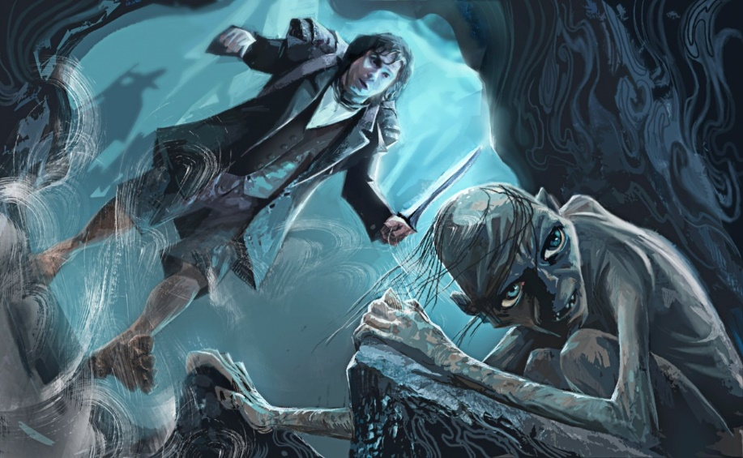
 | Quote from Book | Writing Activity
1 | He could hear nothing, see nothing, and he could feel nothing except the stone of the floor. | Repetition is when a writer uses the same word over again. Write a sentence to explain what Tolkien’s use of repetition emphasises in this sentence?
2 | He got up and groped about on all fours | Imagery is when words create a picture in your head. Draw the picture that you see in your head from this sentence.
3 | His head was swimming | A simile is when something is compared to something else using the words ‘like’ or ‘as’. A metaphor is when something is compared to something else without using the words ‘like’ or ‘as’. Which is the example on the left – a metaphor or a simile?
4 | no sign of goblins, no sign of dwarves. | Is this quote ‘repetition’ or ‘simile’ or ‘metaphor’ or ‘imagery’? Write a sentence explaining why you chose the label?
5 | He put the ring in his pocket almost without thinking; certainly it did not seem of any particular use at the moment. | Write a sentence explaining why you think Tolkien does not tell the reader how important the ring is at this point in the story?
6 | But that only made him miserabler | This quote shows Tolkien’s use of comparative superlatives….Complete the table below to learn more of these comparative words.
7 | He could not think what to do; nor could he think what had happened | The protagonist is the central character in a story. Write some sentences to explain how Tolkien’s use of repetition helps us to get inside the protagonist’s thoughts.
8 | or why he had been left behind; or why, if he had been left behind, the goblins had not caught him; or even why his head was so sore | Write sentences to explain what Tolkien’s use of repetition tells us about how Bilbo was feeling.
Adjective Table
Adjective | Comparative (2 things) | Superlative (3 things)
Miserable | Miserabler or more miserable than | Miserablest or most miserable
Happy
Pretty
Close
Short
Old
Beautiful
Respectable

